**Servo Motor and How to use it**

**Description**: In this project, we will learn how to use Servo Motor.

**Hardware Requirement:**

* Arduino board
* A Sarvo Motor
* Breadboard
* Jumper wire

**Servo Motor:**

A servomotor (or servo motor) is **a rotary actuator or linear actuator that allows for precise control of angular or linear position, velocity and acceleration**. It consists of a suitable motor coupled to a sensor for position feedback.

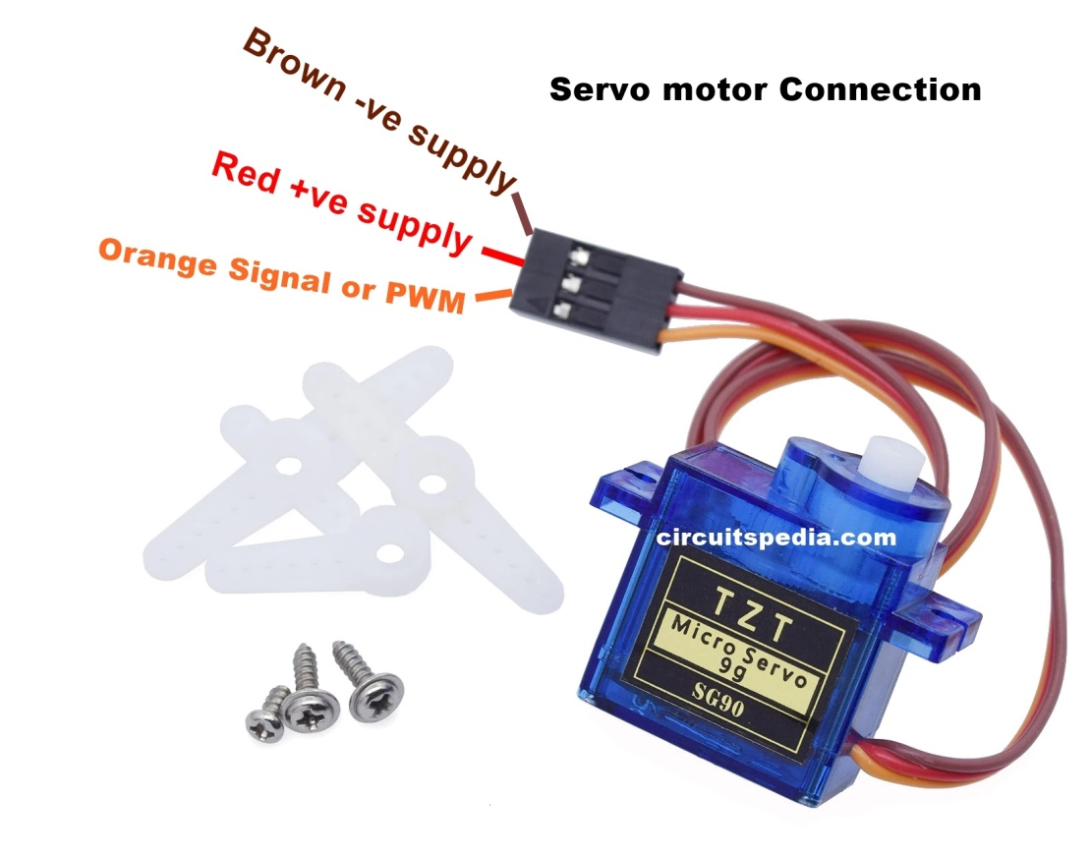

**Connection:**

* Signal or PWM pin connected to arduino’s any PWM pin.
* Red wire connected to 5V
* Brown wire connected to GND

**Circuit Diagram:**

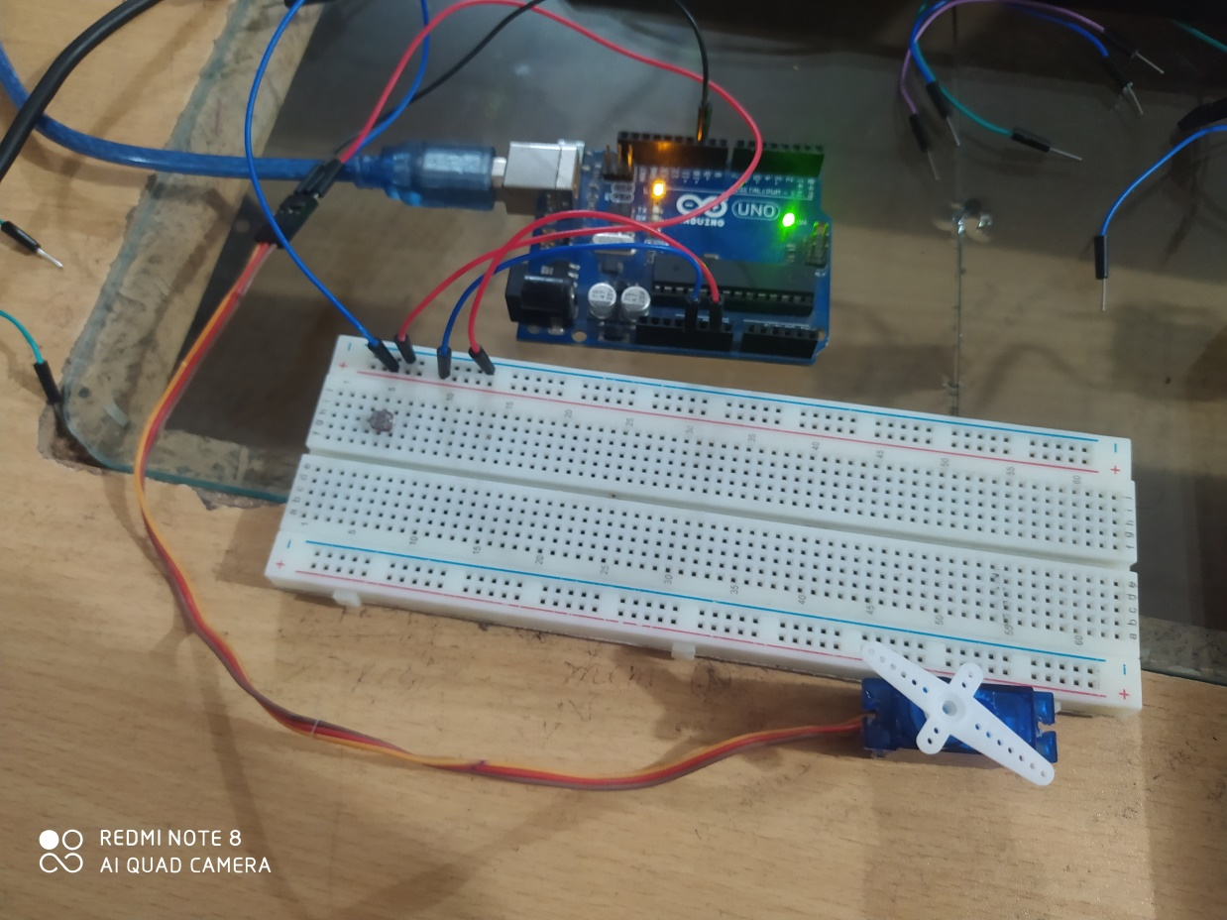

* The servo motor Rotates only from 0 degree to 180 degree.

**Code:**

|  |  |
| --- | --- |
| |  | | --- | | #include<Servo.h> char x; Servo myservo; // initazing myservo void setup() {   // put your setup code here, to run once: myservo.attach(10); // indicate the PWM pin-10  Serial.begin(9600);  }  void loop() {   // put your main code here, to run repeatedly:   if(Serial.available()!=0)   {     x=Serial.read(); // character reading    } if(x=='0') {   myservo.write(0); // survo rotate into 0 degree }  if(x=='1') {    myservo.write(10); // survo rotate into 10 degree }  if(x=='2') {    myservo.write(30); // survo rotate into 30 degree }  if(x=='3') {    myservo.write(60); // survo rotate into 60 degree }  if(x=='4') {    myservo.write(90); // survo rotate into 90 degree } if(x=='5') {    myservo.write(120); // survo rotate into 120 degree }  if(x=='6') {    myservo.write(150); // survo rotate into 150 degree }  if(x=='7') {    myservo.write(180); // survo rotate into 180 degree }  } | |